LAMPIRAN-LAMPIRAN
A.1. Data Sheet
- Data Sheet IC Atmega328P

- Data Sheet MQ-2

- Data Sheet MFRC522
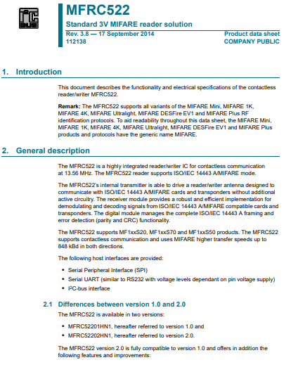

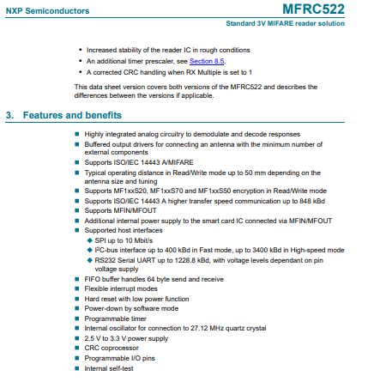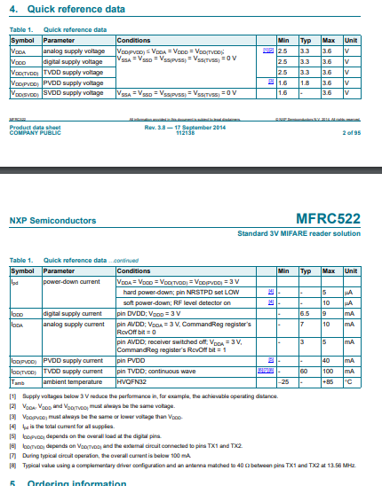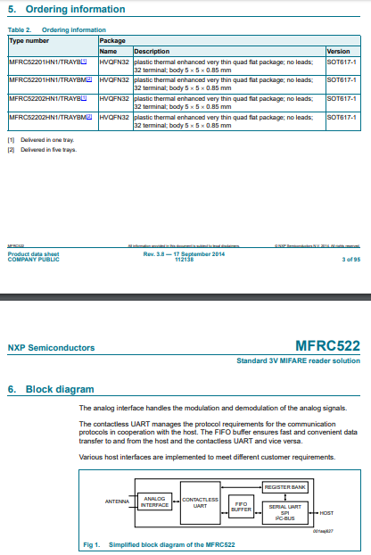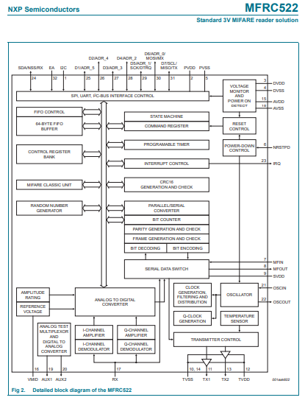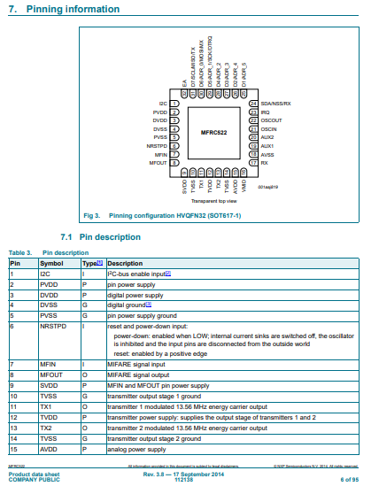
- Data Sheet Sensor Ultrasonik (HC-SR04)

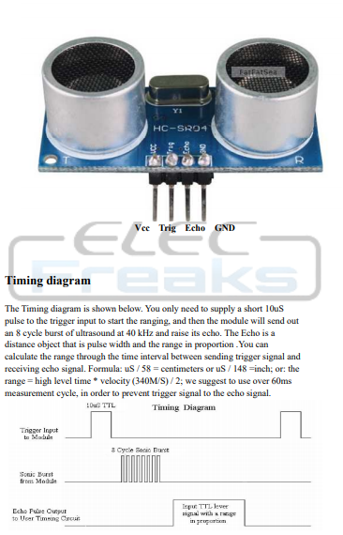

- Data Sheet Modul I2C
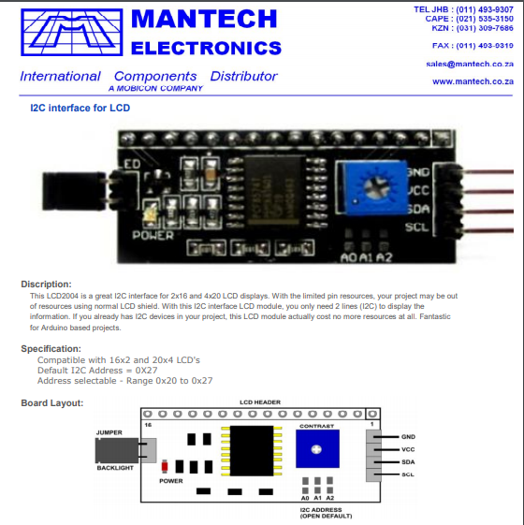
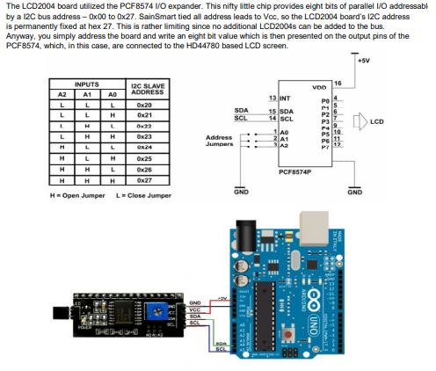

- Data Sheet Motor Stepper 28BYJ-48
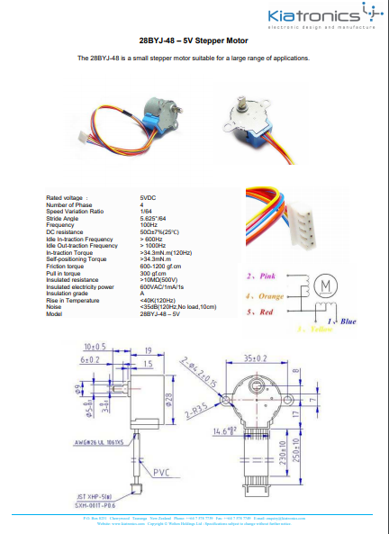

- Data Sheet Motor Driver ULN2003
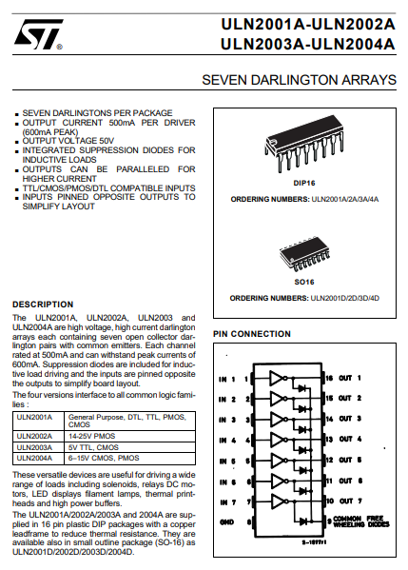
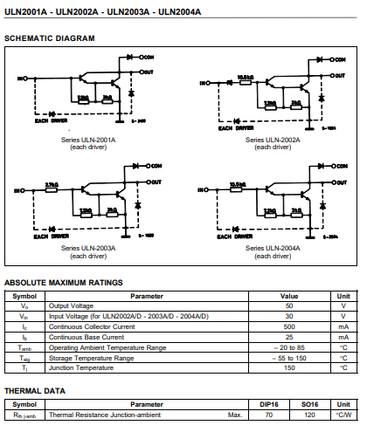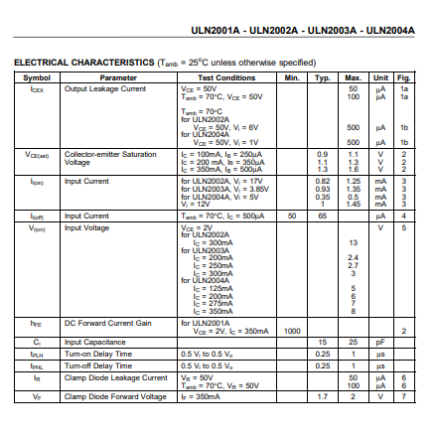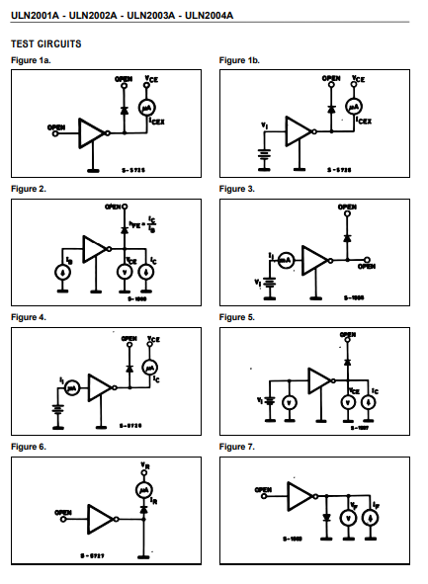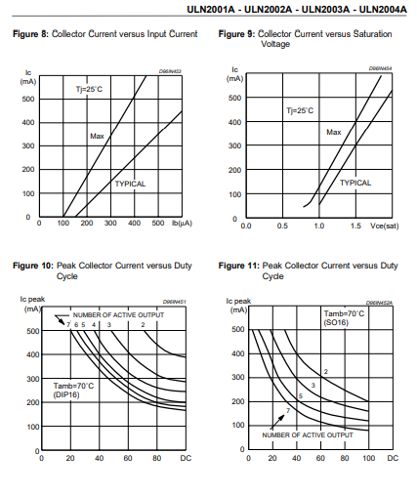
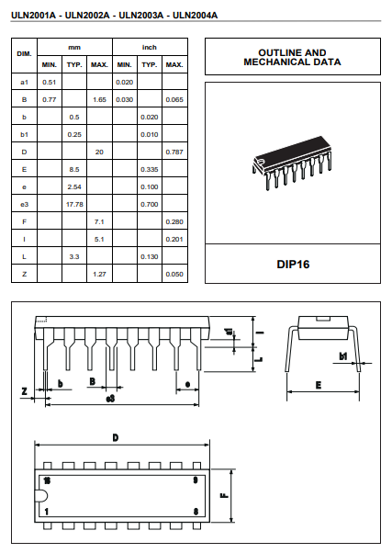

B.1. Listing Program Keseluruhan
#include <SPI.h> // serial peripheral interface
#include <MFRC522.h> // library rfid
#include <Wire.h> // wire virtual
#include <LiquidCrystal_I2C.h> //library lcd i2c
#include <Stepper.h> // library motor stepper

#define SS_PIN 10 // menetapkan pin rfid dengan pin 10 arduino
#define RST_PIN 9 // menetapkan pin rfid dengan pin 9 arduino
#define LED_ACCESS_PIN 7 // pin 7 led pada arduino

#define motorSteps 64 // step dari motor stepper
#define motorPin1 6 // pin IN1 motor driver ULN2003
#define motorPin2 5 // pin IN2 motor driver ULN2003
#define motorPin3 4 // pin IN3 motor driver ULN2003
#define motorPin4 3 // pin IN4 motor driver ULN2003
#define button 8
const int step_ = 1600; //putaran motor stepper
int trigPin = A0; //pin sensor hc-sr04 di A0 arduino
int echoPin = A1; ////pin sensor hc-sr04 di A0 arduino
int button1 = 0; //push button

// initialize of the Stepper library:
Stepper myStepper(motorSteps, motorPin4, motorPin2, motorPin3, motorPin1);
LiquidCrystal_I2C lcd(0x27, 16, 2); // alamat modul i2c
MFRC522 mfrc522(SS_PIN, RST_PIN); // jarak dari modul mfrc522
void setup() // fungsi yang berjalan sekali
{
myStepper.setSpeed(100); // kecepatan motor stepper
// initialize the Serial port:
Serial.begin(9600); // Initiate a serial communication
lcd.begin(); //lcd 16x2
lcd.setCursor(1,0); // posisi text pada lcd
lcd.clear(); //hapus text pada lcd
SPI.begin(); // Initiate SPI bus
mfrc522.PCD_Init(); // Initiate MFRC522
Serial.println("PLEASE TAG YOUR E-KTP CARD to the READER TAG...");
Serial.println();
pinMode( LED_ACCESS_PIN , OUTPUT); // pin led sebagai output
pinMode( echoPin, INPUT ); //pin echo sebagai input
pinMode( trigPin, OUTPUT); // pin trig sebagai output
pinMode( button, INPUT_PULLUP); // pin push button sebagai input
}
void distance1()
{
long duration, distance; //fungsi jarak sensor hc-sr04
digitalWrite(trigPin,HIGH); //pin trig aktif
delayMicroseconds(1000); //delay waktu
digitalWrite(trigPin, LOW);
duration=pulseIn(echoPin, HIGH);
distance =(duration/2)/29.1;
Serial.print(distance);
Serial.println("CM");
if(distance<=10) //jika jarak kuang dari 10cm, sensor bekerja
{
myStepper.step(0); // motor stepper berhenti ketika sensor hc-sr04 memdeteksi jarak yang sesuai
delay(2000); //delay 2detik
digitalWrite(LED_ACCESS_PIN, HIGH); //led menyala
lcd.clear(); //hapus text
lcd.setBacklight(HIGH);
lcd.setCursor(1,0);
lcd.print("ADA OBJEK!"); //text pada lcd
digitalWrite(LED_ACCESS_PIN, HIGH); //led menyala
delay(1000);
digitalWrite(LED_ACCESS_PIN, LOW); // led mati
lcd.clear();
Serial.println("TRUE"); //teks pada serial monitor Arduino IDE
return distance1(); //kembali mendeteksi jarak sensor hc-sr04
}
void buttoon(){ //fungsi dari push button
button1 = digitalRead(button); //membaca push button
if (button1 == LOW) { //jika button di tekan, maka proses akan berjalan
Serial.println("Authorized Access"); //teks di serial monitor
Serial.println();
lcd.setCursor(1, 0);
lcd.println("ACCESS GRANTED"); //teks di lcd ketika akses diijinkan oleh rfid
lcd.println();
lcd.clear();
lcd.setBacklight(HIGH);
lcd.setCursor(4, 0); // intruksi menentukan kursor
lcd.print("Sky Hunter"); //intruksi menulis string/karakter pada lcd 16x2
lcd.setCursor(4, 1);
lcd.print("Project");
Serial.println("BUKA"); // intruksi menulis string/ karakter pada serial monitor
delay(3000);
digitalWrite(7, HIGH); // intruksi pin led 7 di Arduino agar menyala
myStepper.step(step_); // intruksi motor stepper berjalan
lcd.clear();
lcd.setBacklight(HIGH);
lcd.setCursor(2, 0);
lcd.print("PASS THE DOOR");
lcd.setCursor(0, 1);
lcd.print("Welcome to Home");
Serial.println("PASS THE DOOR");
digitalWrite(7, LOW);
delay(6000);

distance1(); // variabel sensor hc-sr04
delay(6000);
lcd.clear();
lcd.setBacklight(HIGH);
lcd.setCursor(4, 0);
lcd.print("CLOSING");
lcd.setCursor(2, 1);
lcd.print("See You ^_^");
Serial.println("CLOSING");
digitalWrite(7, HIGH);
delay(3000);
myStepper.step(-step_);
Serial.println("TUTUP");
digitalWrite(7, LOW);
delay(3000);
lcd.clear();
myStepper.step(-step_); //intruksi motor stepper untuk menutup pagar
Serial.println("TUTUP");
digitalWrite(7, LOW);
delay(3000);
lcd.clear();
}
}

void loop() {
lcd.setCursor(4, 0);
// Print at cursor Location:
lcd.print("ASSALAMUALAIKUM");
//goto column 2 and second line
lcd.setCursor(0, 1);
lcd.print("Sky Hunter Team ");
buttoon();
// Look for new cards
if ( ! mfrc522.PICC_IsNewCardPresent()) //inisialisasi rfid
{
return;
}
// Select one of the cards
if ( ! mfrc522.PICC_ReadCardSerial()) //baca kartu
{
return;
}
//Show UID on serial monitor
Serial.print("UID tag :");
String content= "";
byte letter;
for (byte i = 0; i < mfrc522.uid.size; i++)
{
Serial.print(mfrc522.uid.uidByte[i] < 0x10 ? " 0" : " ");
Serial.print(mfrc522.uid.uidByte[i], HEX);
content.concat(String(mfrc522.uid.uidByte[i] < 0x10 ? " 0" : " "));
content.concat(String(mfrc522.uid.uidByte[i], HEX));
}
Serial.println();
Serial.print("Message : ");
content.toUpperCase()
if (content.substring(1) == "04 28 5D 4A F9 2C 80") // nomor tag kartu yang mendapat akses
{
Serial.println("Authorized access");
Serial.println();
lcd.setCursor(1, 0);
lcd.println("ACCESS GRANTED");
lcd.println();
lcd.clear();
lcd.setBacklight(HIGH);
lcd.setCursor(4, 0);
lcd.print("OPENING");
lcd.setCursor(4, 1);
lcd.print("GARAGE");
Serial.println("BUKA");
delay(3000);
digitalWrite(7, HIGH);
myStepper.step(step_);
lcd.clear();
lcd.setBacklight(HIGH);
lcd.setCursor(2, 0);
lcd.print("PASSED");
lcd.setCursor(0, 1);
lcd.print("Welcome to Home");
Serial.println("PASSED");
digitalWrite(7, LOW);
delay(6000);
distance1();
delay(6000);
lcd.clear();
lcd.setBacklight(HIGH);
lcd.setCursor(4, 0);
lcd.print("CLOSING");
lcd.setCursor(2, 1);
lcd.print("See You ^_^");
Serial.println("CLOSING");
digitalWrite(7, HIGH);
delay(3000);
myStepper.step(-step_);
Serial.println("TUTUP");
digitalWrite(7, LOW);

delay(3000);
lcd.clear();
myStepper.step(-step_);
Serial.println("TUTUP");
digitalWrite(7, LOW);
delay(3000);
lcd.clear();
}
Else //jika kartu di tolak maka tidak ada proses berjalan
{
Serial.println("ACCESS DENIED"); //keluaran teks di serial monitor ketika akses ditolak
digitalWrite(7, HIGH);
delay(100);
digitalWrite(7, LOW);
delay(100);
digitalWrite(7, HIGH);
delay(100);
digitalWrite(7, LOW);
delay(100);
digitalWrite(7, HIGH);
delay(100);
digitalWrite(7, LOW);
delay(100);
Serial.println(" Access denied");
Serial.println();
lcd.clear();
lcd.setBacklight(HIGH);
lcd.setCursor(1, 0);
lcd.print("Access Denied");
delay(3000);
lcd.clear();
}
lcd.clear();
}

C.1. Skema Rangkaian Keseluruhan
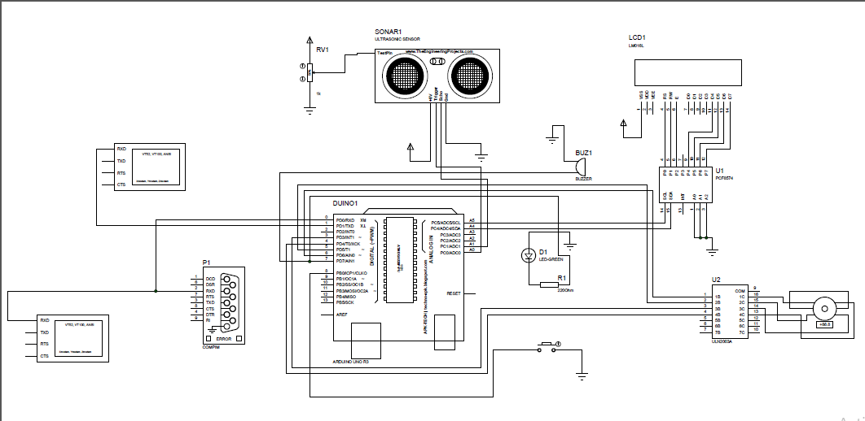

D.1. Daftar Komponen dan Daftar Harga
No | Nama Komponen | Harga (Rp)
1 | (1pcs) Arduino Uno | Rp. 95.000,-
2 | (1pcs) Sensor HC-SR 04 | Rp. 30.000,-
3 | (1pcs) Modul I2C | Rp. 25.000,-
4 | (1pcs) Buzzer | Rp. 7.500,-
5 | (40pcs) Kabel Male – Female | Rp. 40.000,-
6 | (1pcs) PCB 10x20cm | Rp. 7.000,-
7 | (5pcs) LED | Rp. 1500,-
8 | (1pcs) Resistor | Rp. 100,-
9 | (1pcs) Kabel Jumper | Rp. 2.000,-
10 | (1pcs) Modul RFID MFRC522 | Rp. 35.000,-
11 | (1pcs) BreadBoard | Rp. 10.000,-
12 | (1pcs) Motor Driver ULN2003 | Rp. 25000,-
13 | (4pcs) Push Button | Rp. 2000,-
Total Harga Rp. 280.100,-

E.1. Foto Alat
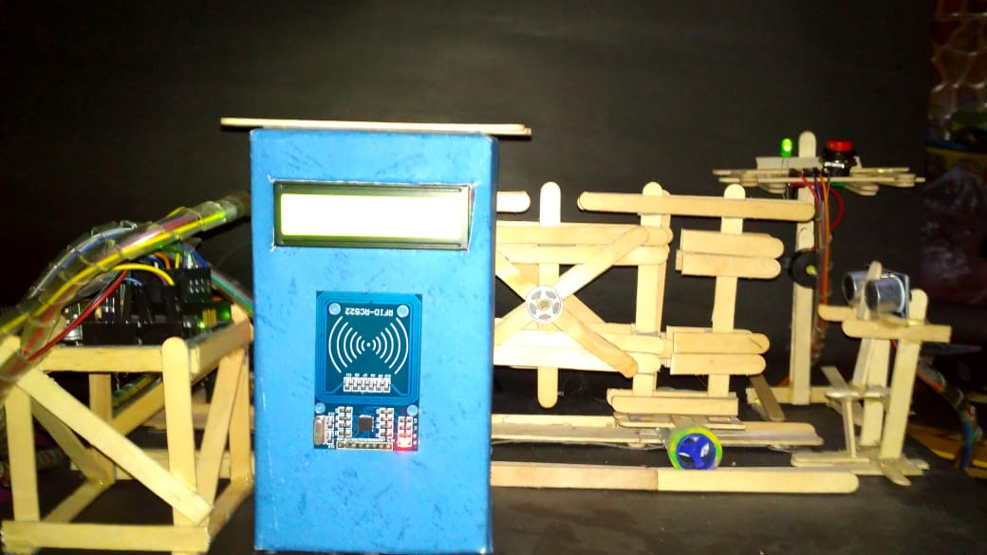
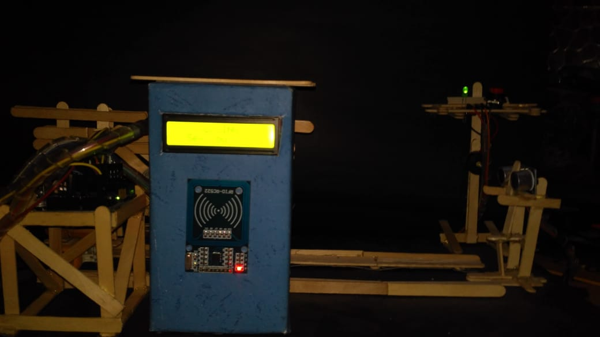

F.1. Tampilan Serial Monitor Arduino IDE
1. Tampilan Serial Monitor
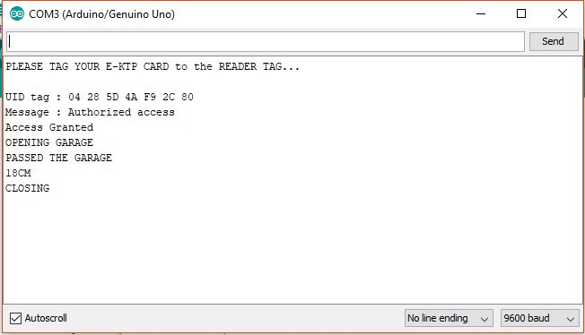
a). Tampilan Serial monitor saat – akses kartu diijinkan dan memulai proses
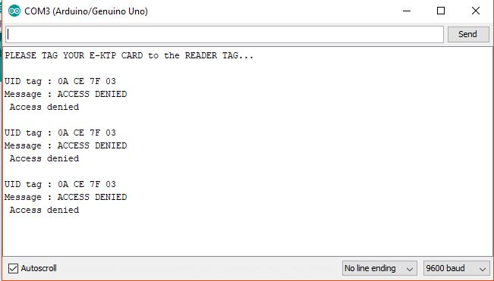
b). Tampilan Serial Monitor- saat akses kartu di tolak.

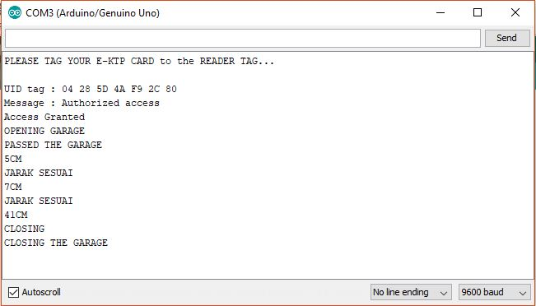

c). Tampilan Serial Monitor- saat sensor HC-SR04 mendeteksi objek ketika ada objek yang berhenti saat pagar sedang menutup

